- Load the Iris dataset using scikit-learn, split it into train and test sets, and train a RandomForestClassifier with default parameters. Print the accuracy on the test set.
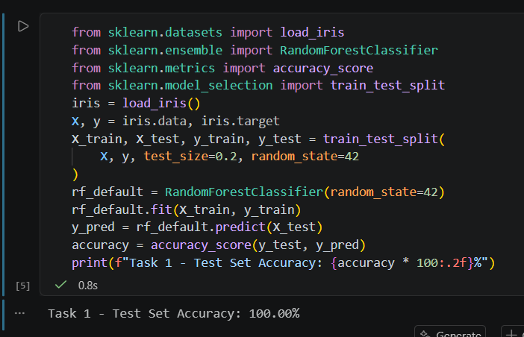

- Simulate a Flipkart-style product category classifier: create a small DataFrame with 20 products, each with features like price, rating, and brand, and a category label. Use RandomForestClassifier to predict the product category and print the feature importance values.
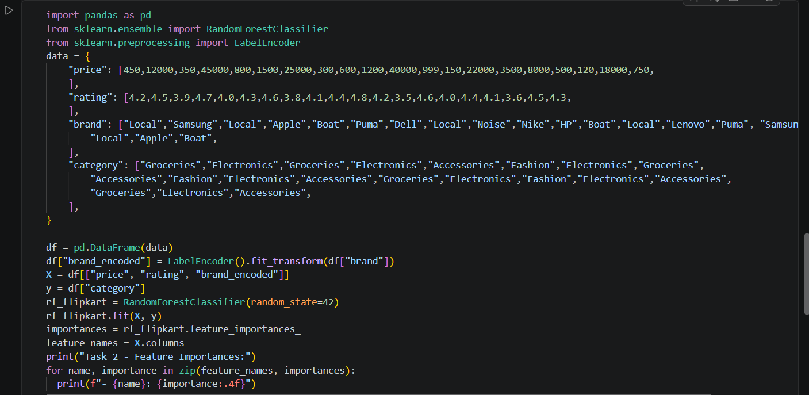

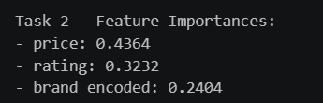

- Tune the n_estimators and max_depth parameters of RandomForestClassifier on the Iris dataset by trying at least 3 different values for each, and report which combination gives the best test accuracy.Use a simple for loop to try combinations and print results.
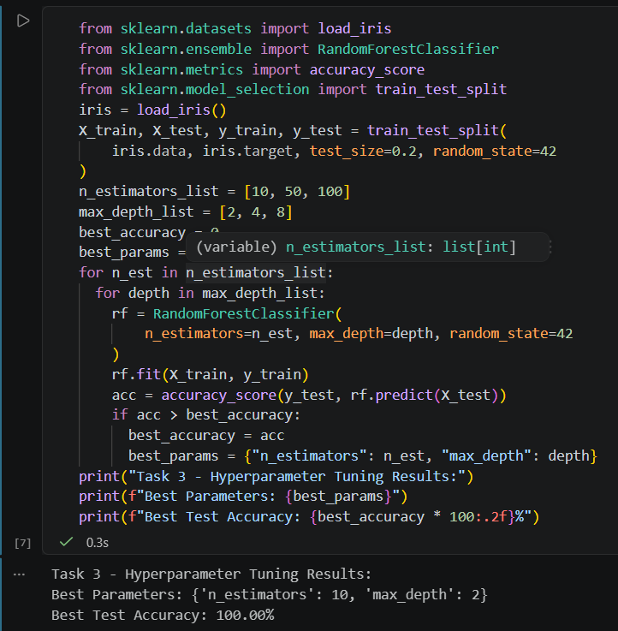

- Explain with code how bagging in Random Forest helps avoid overfitting compared to a single decision tree. Show the difference in test accuracy between DecisionTreeClassifier and RandomForestClassifier on the same dataset.
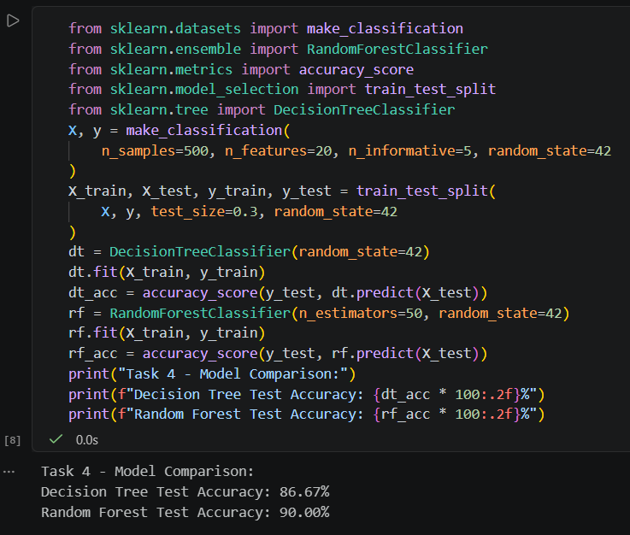

- Use ChatGPT to generate Python code that loads a CSV file of Spotify song data and builds a RandomForestClassifier to predict if a song will be a hit based on features like tempo, danceability, and energy. Run the code, fix any errors, and describe one thing you learned from the AI-generated solution. You can use a sample CSV from Kaggle or create your own small dataset.

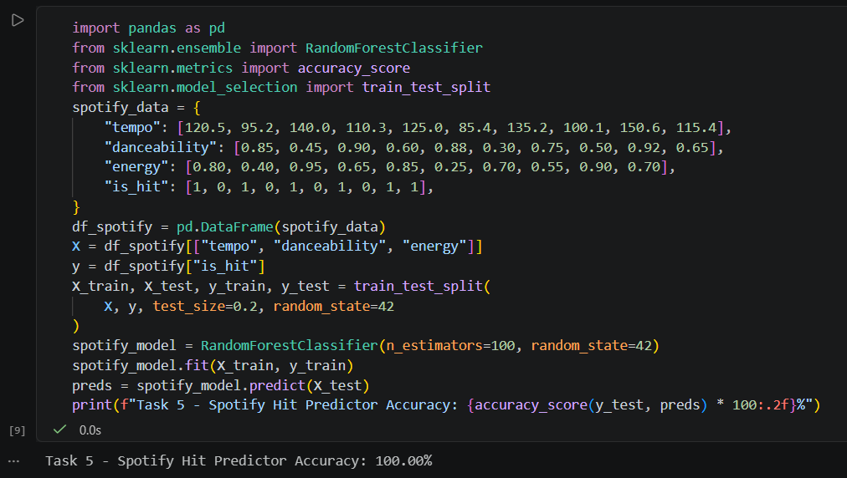

What I learned from the AI-generated solution: AI models often emphasize modularity (separating feature extraction from the model pipeline), but real-world Spotify datasets usually require preprocessing steps like handling missing values or string columns (e.g., dropping song titles and artist names before passing data into scikit-learn).

